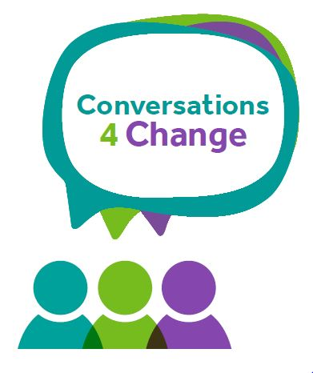
Early Help
Celebrate & Sustain Change

SECTION 1 Family Information
Family Information (include all those living in the family home)
If unborn, state name as ‘unborn baby’ and mother’s name, e.g. unborn baby of Ann Smith.
Children and Young People
Name | Date of Birth | Gender M/F | Ethnicity |  | Disability (please specify if appropriate)
Parents /Carers
Name | Date of Birth | Gender M/F | Ethnicity | Disability  (please specify) |  | Relationship

Key Information

Reason for Early Help Involvement (Please provide a brief summary of the presenting concerns)

Summary of progress

Date of request for EH service__________________________________________________

Date of last check in on change?_______________________________________________

Who is the lead professional going forward?______________________________________

Statement Details
Area of Life | INITIAL Outcome Star Score  (please score each area between 1-10  For the INITIAL score) | FINAL Outcome Star Score  (  please score each area between 1-10  For the FINAL score) | Summary of the journey of the family
Physical Health
Your Wellbeing

Meeting emotional needs
Keeping your children safe
Social networks
Education & Learning
Boundaries & Behaviour
Family routine
Home & Money
Progress to work

Completion dates and Management Authorisation

Name of Family Support Worker:
Date summary completed:
Date field
Name of Authorising Manager:
Drop down menu
Date summary signed off:
Date field

